How Meiosis and Fertilization Produce Genetic Diversity

(In Contrast to Asexual Reproduction)

You have learned how meiosis and fertilization transmit genes from parents to offspring. In this activity, you will learn more about how meiosis and fertilization produce genetic diversity. To learn more, you will follow the alleles of these three human genes during meiosis and fertilization.

Genotype | → | Protein | → | Phenotype (characteristics)
AA or Aa | → | Enough functional enzyme to make melanin, the pigment molecule that gives skin and hair their color | → | Normal skin and hair color
aa | → | Non-functional enzyme that cannot make melanin | → | Very pale skin and hair color; albinism
HH or Hh | → | Enough normal hemoglobin to maintain normal shape and function of red blood cells | → | Normal disk-shaped red blood cells that can just squeeze through the smallest blood vessels
hh | → | Sickle cell hemoglobin, which can clump in long rods, which cause red blood cells to become stiff and elongated. | → | Stiff, elongated red blood cells can block blood flow in the smallest blood vessels, which causes pain and organ damage; fragile red blood cells; sickle cell anemia
II or Ii | → | Non-functional enzyme that cannot dispose of harmful molecules produced by the metabolism of alcohol | → | Discomfort and skin flush after drinking alcohol; alcohol intolerance
ii | → | Functional enzyme that disposes of harmful molecules produced by alcohol metabolism | → | Not alcohol intolerant

1a. What is represented by the two letters in each genotype?

1b. Danielle has the combined genotype AaHhIi. What is Danielle’s phenotype?

2a. In the previous activity, you learned how a Punnett square summarizes the possible outcomes of meiosis and fertilization. To demonstrate one way that meiosis and fertilization can result in genetic diversity, draw a Punnett square for two Aa parents.

2b. Put an asterisk (*) next to the zygote that will develop into a baby with a different phenotype from his/her parents.

Your answer to question 2 shows one way that meiosis and fertilization can result in genetic diversity, which can lead to diverse phenotypes. The other ways that meiosis contributes to genetic diversity involve two or more genes.

At the beginning of meiosis, pairs of homologous chromosomes line up next to each other. This figure shows one chromosome that began meiosis with the A and H alleles and the homologous chromosome with the a and h alleles.  Crossing over occurred when the two homologous chromosomes exchanged parts of their chromatids.  3. Label the alleles for these genes on each chromatid of the chromosomes in the bottom row, after crossing over.  4. After meiosis separates the homologous chromosomes and the sister chromatids, the gametes will have four different combinations of the alleles for these two genes. The combinations of alleles in the different gametes will be:  _AH_ _______ _______ _______ . | 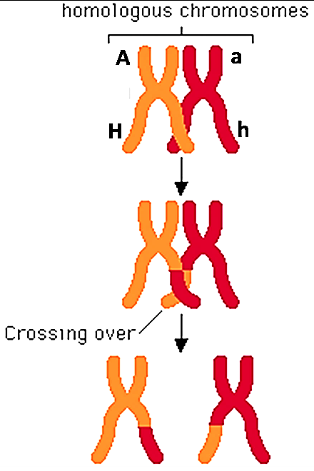

Another process that contributes to the genetic diversity of eggs and sperm is only observed if there are two or more pairs of homologous chromosomes. The figure below shows that two pairs of homologous chromosomes can line up in two different ways at the beginning of meiosis. This is called independent assortment, since each pair of homologous chromosomes lines up independently of how the other pairs of homologous chromosomes line, up.

5. Complete this chart. Draw the missing chromosomes and label the alleles on each chromatid and chromosome. Fill in the blanks to describe the combinations of alleles in the gametes.

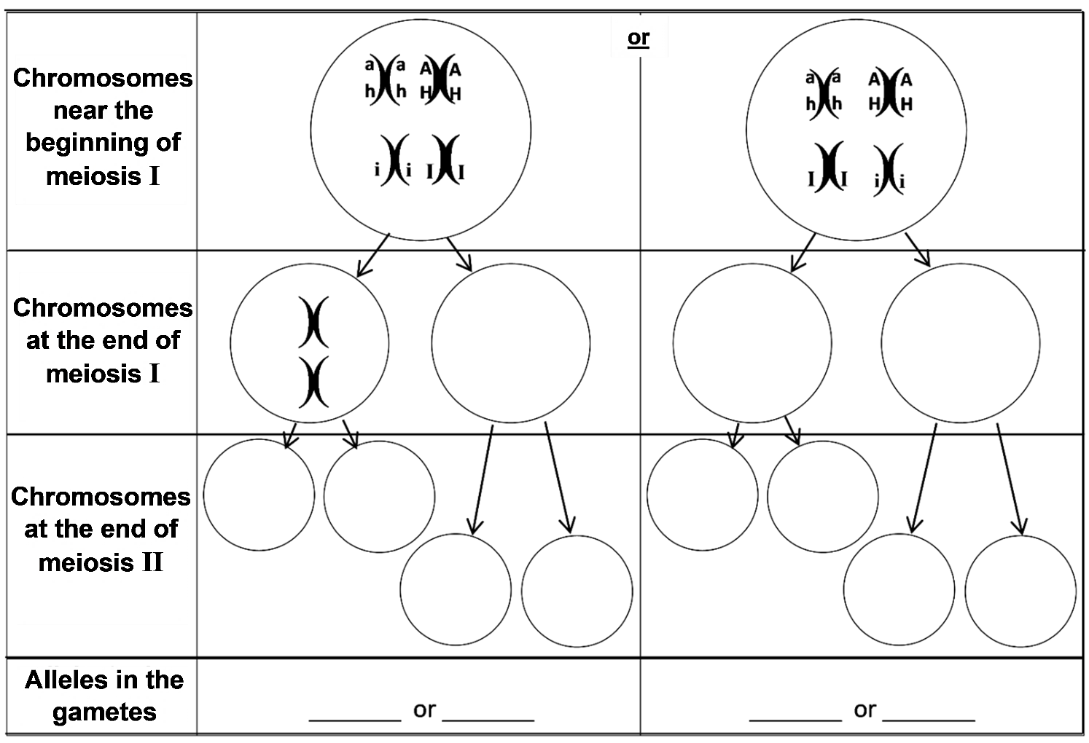

6a. Suppose that Danielle and her husband both have the AaHh genotype, with chromosomes like those shown here. These parents would have normal skin and hair color and normal red blood cells. Explain how they could have a child with albinism and sickle cell anemia. | 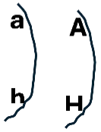

6b. Explain how Danielle and her husband could have a child with albinism, but not sickle cell anemia.

7. In question 5, you analyzed the outcomes of meiosis for a parent who had the AaHhIi genotype with the chromosomes shown here. You saw that independent assortment resulted in gametes with four different combinations of these alleles. What additional process during meiosis could produce gametes with these four additional combinations of alleles – aHi, aHI, AhI and Ahi? | 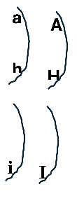
You have shown that crossing over and independent assortment during meiosis can produce gametes with eight different combinations of the alleles for these three genes. Each human body cell has thousands of genes in 23 pairs of homologous chromosomes. Independent assortment of 23 pairs of homologous chromosomes can produce more than 8 million different combinations of chromosomes in different gametes produced by the same person! Crossing over results in an even greater number of different combinations of alleles in these gametes.

8. Since independent assortment alone can generate more than 8 million combinations of chromosomes in the gametes produced by each parent, what is the minimum number of combinations of chromosomes in the possible zygotes produced by these two parents? (To answer this question, imagine that each different type of egg from one mother could be fertilized by each different type of sperm from one father.)

9. Explain why no two siblings inherit exactly the same combination of alleles from their parents (except for identical twins who both developed from the same zygote). A complete answer will include the following terms:
meiosis, genes, alleles, pair of homologous chromosomes, independent assortment,
crossing over, gametes, millions, egg, sperm, fertilized or fertilization, zygote, trillions.

Comparing Sexual Reproduction with Asexual Reproduction

Thus far, we have discussed sexual reproduction in humans. Asexual reproduction involves only mitosis, without meiosis or fertilization. Asexual reproduction occurs in some types of animals and many types of plants.
This figure shows one type of asexual reproduction. Repeated mitosis produces the cells that form a bud. Then, the bud breaks off to form a new hydra.  10a. Are there any genetic differences between the parent hydra and the new hydra? yes ___ no ___  10b. Explain your reasoning. | 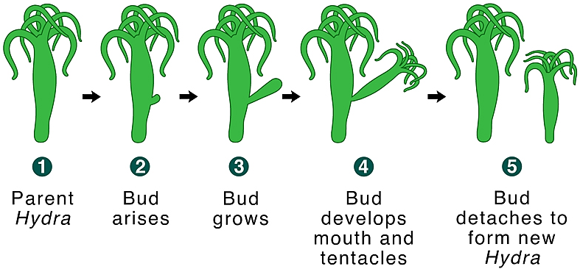  A hydra is an animal that lives in water and uses its tentacles  to catch food.

Another example of asexual reproduction is a clone of genetically identical aspen trees, each sprouting from a shared root system. Over many years, these clones can grow to a very large size. One giant aspen clone contains about 47,000 trees and extends over more than 100 acres.

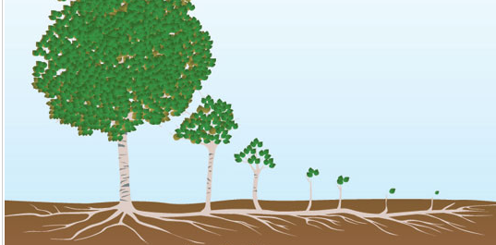

11. Sexual reproduction involves ___ parent(s) and produces genetically ______________ offspring.
(0/1/2) (diverse/identical)
Asexual reproduction involves ___ parent(s) and produces genetically ________________ offspring.
(0/1/2) (diverse/identical)

12a. What would be the advantage of asexual reproduction for an organism that grows in a stable environment that does not change?

12b. What would be the advantage of sexual reproduction for an organism that grows in a variable environment that often changes?

By Drs. Ingrid Waldron, Jennifer Doherty, R. Scott Poethig, and Lori Spindler, Biology Dept, Univ Pennsylvania, © 2025. This Student Handout and Teacher Notes with background information and instructional suggestions are available at https://serendipstudio.org/exchange/bioactivities/gendiversity.

